Front Cover

The impact of social media marketing in promoting tourism businesses: with special reference to Manchester City, UK

Title Page

Acknowledgments

I would like to take this opportunity to express my heartfelt gratitude to all those who, in one way or the other, assisted and guided me through this research. Above all, I am deeply indebted to my supervisor, [Supervisor's Name], for his very important suggestions, unending encouragement, and helpful remarks, which contributed to raising the quality of this effort. Without his mentorship, this study would not have been achieved.
I am indeed very grateful to the faculty and staff at [Your University] who imparted knowledge and supported me with the resources necessary for this research. Thanks also go out to all my colleagues and classmates who, through constructive criticism and motivation, kept reminding me to focus when situations got tough.
I am also grateful to the respondents of this study, most especially to those who participated in managing tourism businesses within Manchester City, for taking the time and showing their willingness to share their insights. This helped a lot in completing this research.
I would lastly want to thank my family and my friends for their continued support and, thus, encouragement through these years of academics. Their patience and understanding have been a constant source of strength.

Abstract
This research is aimed at investigating the effects of social media marketing on promoting tourism businesses, taking into consideration the City of Manchester, UK. The selection of social media platforms, tactics for inducing engagement, and the way content strategy is developed, affecting the visibility and promotion of tourism businesses, were studied using Instagram, Facebook, and Twitter as essential marketing tools. This study will, therefore, help to bridge the literature gap by providing empirical evidence concerning the role that social media marketing can play in the tourism sector, considering Manchester in its unique context as a growing tourism hub.
This study will adopt a quantitative approach through the use of structured questionnaires to survey 130 owners and managers of tourism businesses in Manchester. Data analysis was done through descriptive statistics, correlation, and regression analysis to attain results on how social media strategy is used in promoting tourism. These various analyses were done with the use of SPSS software to systematically appraise key variables of platform selection, tactics of engagement, and content strategy.
The key findings indicate that all three variables are influential in the promotion of tourism businesses, and this influence is most evident in content strategy. Other effective strategies of engagement tactics reportedly increase brand visibility as well as customer engagement. However, platform selection does play a role, though less crucial than the other two elements of engagement and content strategies, in tourism business promotion.
It offers practical implications for tourism marketers, entrepreneurs, and policymakers. Using the appropriate selection of the platform, creative strategies of engagement, and content can help a tourism business to better its social media presence and thereby its chances of aiding in tourism growth. These findings can therefore be used to direct practitioners on how they could communicate better through more effective marketing campaigns that would yield the fullest potential of social media to benefit the tourism sector in Manchester and elsewhere.
Keywords: Social media marketing, Platform selection, Engagement tactics, Content strategy, Tourism business promotion

Declaration

I, [Your Name], declare that this research is wholly my work unless otherwise referenced or acknowledged and the work described in this report was carried out by me under the supervision of [Supervisor name]. This report has not been submitted in whole or in part to any university/ institution for another qualification.

Signature:
Your Name:
Date:
Table of Contents
Acknowledgments iii
Abstract iv
Declaration v
List of Tables ix
List of Figures x
Chapter 1: Introduction 1
1.1 Background of Research 1
1.2 Research Problem 2
1.3 Rationale of Research 2
1.4 Scope of Research 3
1.4.1 Research Question 3
1.4.2 Research Aim 3
1.5.2 Objectives 3
1.6 Snapshot of Methodology 4
1.7 Structure of Research 4
1.8 Summary 5
Chapter 2: Literature Review 6
2.1 Introduction 6
2.2 Theoretical Framework 6
2.2.1 Technology Acceptance Model (TAM) 6
2.2.2. Social Exchange Theory (SET) 7
2.3 Define the Keywords on the Research Topic 8
2.3.1 Social Media Marketing 8
2.3.2 Platform Selection 8
2.3.3 Engagement Tactics 9
2.3.4 Content Strategy 9
2.4 Central Theme, Analytical Models, and Applicability to Research Objectives 10
2.4.1 Impact of Platform Selection on Promoting Tourism Businesses in Manchester City 10
2.4.2 Impact of Engagement Tactics on Promoting Tourism Businesses in Manchester City 12
2.4.3 Impact of Content Strategy on Promoting Tourism Businesses in Manchester City 14
2.5 Conceptual Framework 15
2.6 Hypotheses Formulation 16
2.7 Research Gap 16
2.8 Conclusion 17
Chapter 3: Research Methodology 18
3.1 Introduction 18
3.2 Philosophy 18
3.3 Research Approach 19
3.4 Research Methods 19
3.5 Data Collection Techniques 20
3.6 Sample and Sampling 21
3.7 Research Ethics 21
3.8 Summary 22
Chapter 4 Findings and Analysis 23
4.1 Introduction 23
4.2 Demographic Analysis 23
4.3 Reliability Analysis 25
4.3.1 Reliability Analysis for All the Survey Questions 25
4.3.2 Reliability Analysis for the Statements of Each Variable 26
4.4 Data Presentation and Interpretation 27
4.4.1 Descriptive Statistics Analysis 27
4.4.2 Correlation Analysis 28
4.4.3 Multiple Regression Analysis 29
4.5 Analysis of the Findings and Discussion 31
4.6 Summary 36
Chapter 5: Conclusion, Recommendations, and Managerial Implications 37
5.1 Introduction 37
5.2 Conclusions for Research Objectives 37
5.2.1 Objective 1: To investigate the impact of platform selection on promoting tourism businesses in Manchester, UK. 37
5.2.2 Objective 2: To investigate the impact of engagement tactics on promoting tourism businesses in Manchester, UK. 38
5.2.3 Objective 3: To investigate the impact of content strategy on promoting tourism businesses in Manchester, UK. 38
5.3 Conclusion for Research Question 39
5.4 Recommendations 39
5.6 Managerial Implications 41
5.7 Limitations of Study 42
5.8 Recommendations for Future Research 42
References 44
Appendices 48
Normality Test of the Variables 48
Multicollinearity Test of Independent Variables 50
Survey Questionnaire 51

List of Tables

Table 1: Summary of frequency rate 25
Table 2: Reliability statistics and ANOVA for all the Likert scale statements 25
Table 3: Reliability statistics for the statements of each variable 26
Table 4: Descriptive statistics for each variable 27
Table 5: Correlation statistics for each variable 28
Table 6: Model Summary for regression analysis 29
Table 7: ANOVA for regression analysis 30
Table 8: Coefficients values for regression analysis 31

List of Figures

Figure 1: Conceptual model of Social Media Marketing impact on Tourism Business Promotion in Manchester City 16
Figure 2: Survey Respondents Distribution Based on Their Gender 23
Figure 3: Survey respondents' distribution based on their tourism business type 24
Figure 4: Survey respondents' distribution based on their experience in tourism businesses 24
Figure 5: Linear graph for Tourism business promotion and Platform selection 32
Figure 6: Linear graph for Tourism business promotion and engagement Tactics 34
Figure 7: Linear graph for Tourism business promotion and Content Strategy 35
Figure 8: Conceptual framework after analyzing the survey results 36

Chapter 1: Introduction

1.1 Background of Research
Social media has changed dramatically the way tourism marketing is conducted today, providing opportunities for engagement and promotion that were previously unimagined. Currently, Facebook, Instagram, and Twitter are the most commonly used channels that national tourist organizations and hospitality companies use to promote destinations and communicate with their prospective tourists in an attempt to influence their travel decisions (Hays, Page, & Buhalis, 2012). Sharing experiences, reviews, and recommendations in real life is possible through these platforms, which bear on tourist behavior and preferences (Sarkar & George, 2018).
In the UK, social media has particularly carried out its role in increasing the visibility of tourism destinations and even in relationship marketing. For instance, in the UK, hotels have utilized social media in the establishment and nourishment of relationships with consumers with the view of establishing loyal customers who would return to repeat purchases from the respective business (Jung, Ineson, & Green, 2012). More precisely, it has been supported that the visual appeal of Instagram influences travel intentions and behaviors (Archenti, 2023).
Despite all these benefits, there are several challenges associated with social media marketing. These include the daily demands of keeping the content relevant and engaging and the constantly changing algorithms that marketers need to keep updating themselves on for better visibility and effectiveness (Kavoura & Stavrianea, 2021). Further, authenticity may be a problem in user-generated content, as it might result in misrepresentation and create expectations that may not materialize (Chung & Han, 2017). Recent research shows that social media is playing a big role in sustainable tourism, which relies on green practices promoting and destinations showcasing some attributes of sustainability. Social media can stand as an important means of escalating awareness of sustainable practices among tourists, thus saving the environment and cultural heritage (Sin, Mohamad, & Lo, 2020).
Manchester is one of the most vibrant and culturally rich places in the UK, and gives a different dimension to the case study on the influence of social media marketing on tourism businesses. Manchester has huge engagement on social media, playing a significant role in promoting its tourist products. Tourism contributed £9 billion to the economy of Manchester in 2020 and supported more than 100,000 jobs. Before the pandemic, Manchester had seen 10 million staying visitors and 120 million day visitors per annum (CityCo, 2024). The hotel market also has over 4,000 new hotel rooms, and this number is likely to be opened by 2021-2024, increasing the total capacity to over 15,000 rooms within the city center by 2024. All these figures underline the enormous role that tourism has come to play as an economic factor for Manchester, hence the huge potential for effective social media marketing in this area.
It is important to understand the dynamics of social media marketing among tourism stakeholders in Manchester. Social media can help to increase destination awareness, support closer customer relationships, and encourage sustainable tourism practices. Hence, this study will attempt to establish features of social media marketing that efficiently and effectively promote tourism business in Manchester City so that tourism stakeholders would adjust their marketing strategies accordingly.

1.2 Research Problem
Despite social media marketing being highly useful in promoting tourism business in various contexts, it is under-explored in Manchester City in the UK. While previous studies show the potential of social media in increasing destination visibility and tourist engagement (Hays, Page, & Buhalis, 2012; Sarkar & George, 2018), there is a lack of clarity to show how such platforms influence tourism in Manchester. While the rapid growth of the city's hotel market and high social media engagement may suggest there must be some strong link, the mechanisms and efficiency of those strategies remain to be explored (Gretzel & Yoo, 2014; Jung, Ineson, & Green, 2012). On the other hand, different kinds of research argue about the reliability of user-generated content and emphasize the burden of keeping the social media presence dynamic which complicates the overall picture (Chung & Han, 2017; Kavoura & Stavrianea, 2021). The current study aims to seek these ambiguities with an understanding of how Manchester tourism businesses are affected by social media marketing, adding to an in-depth understanding of the role of digital marketing within this sector.

1.3 Rationale of Research
This study is motivated by the need to establish the nuanced role of social media marketing in Manchester's tourism sector. A city with a thriving tourism industry and an equally vibrant social media presence, this destination is well suited to investigate the effectiveness of different features of social media marketing in promoting tourism activities. This research will attempt to fill the gap in extant literature with empirical evidence on investigating the influence of social media marketing on promoting tourism business (Buhalis & Sinarta, 2020).
Theoretical and practical implications will be high concerning the findings of this study. Theoretically, the research will add to the current understanding of the role of social media in tourism marketing and sustainable tourism development (Sarkar & George, 2018). This research will offer insight into best practices of how to maximize the usage of social media to effectively increase destination attractiveness and promote sustainable tourism practices, considering a specific case of Manchester (Gebreel & Shuayb, 2022).
Hence, the research will turn out beneficial in guiding tourism marketers and policymakers. Knowledge from the study may be used to inform NTOs and other stakeholders on the best methods of ensuring efficient use of social media platforms to get better marketing results and for greater strides towards responsible initiatives of tourism (Kim, Kim, & Gretzel, 2020; (Kavoura & Stavrianea, 2021). The dynamics of engagement on social media can help tourism businesses prepare better marketing strategies in line with sustainable tourism goals.

1.4 Scope of Research
The current study primarily focuses on the effect of social media marketing, highlighting the key features like platform selection, engagement tactics, and content strategy on promoting tourism businesses within the context of Manchester City in the UK. This study mainly targets the tourism businesses in Manchester City to collect data and analyze them using quantitative methods. The findings of this study will provide valuable insights to researchers and tourism business owners, as well as, policymakers who live in Manchester City.

1.4.1 Research Question
What is the impact of social media marketing in promoting tourism business within Manchester City, UK?

1.4.2 Research Aim
This research project aims to investigate the impact that platform selection, engagement tactics, and content strategy-related social media marketing have had on the promotion of businesses in the tourism sector in Manchester, UK, and to offer suggestions for improving marketing methods in this industry.

1.5.2 Objectives
- To investigate the impact of platform selection on promoting tourism businesses in Manchester, UK.
- To investigate the impact of engagement tactics on promoting tourism businesses in Manchester, UK.
- To investigate the impact of content strategy on promoting tourism businesses in Manchester, UK.
- To recommend methods of promoting methods in tourism industry.

1.6 Snapshot of Methodology
This research uses quantitative techniques in search of finding out the influence of social media marketing on promoting tourism businesses within Manchester, UK. In this study, data will be collected through a structured survey questionnaire targeting owners and managers in tourism businesses, including hotels, travel agencies, and other tourism attraction areas in Manchester City. This research study focuses on the following three main objectives: the influence of platform selection, engagement tactics, and content strategy on promoting tourism businesses, as well as, hypotheses derived to test the influence of those social media marketing features on promoting tourism businesses. This paper will analyze data using the SPSS software, with applied techniques that include descriptive statistics, correlation analysis, and regression analysis. These statistical techniques will allow us to identify which social media marketing features are effective in promoting tourism businesses within the context of Manchester, UK.

1.7 Structure of Research
This research project consists of five chapters as follows;
Chapter 1: Introduction - Outlines the background of the research, statement of the problem, objectives, and significance.
Chapter 2: Literature Review - Review a wide range of literature related to social media marketing and promoting tourism businesses to identify the research gaps.
Chapter 3: Methodology - Describes how the research design, methods of data collection, sampling procedures, and analytical techniques were carried out.
Chapter 4: Data Analysis - Presents and analyzes data using SPSS, together with hypothesis testing and statistical results. The findings are interpreted in the light of prior literature to discuss their implications for theory and practice.
Chapter 5: Conclusion and Recommendations - Summarize the major findings; practical recommendations to tourism businesses; and suggested directions for further research.

1.8 Summary
This chapter presents the overview of the research: an evaluation of how social media marketing influences the promotion of tourism businesses in Manchester, UK. This puts in perspective the background of the transformative role of social media in tourism marketing, the identification of the problem statement, and the setting of the rationale behind the study. The chapter outlines the aim, objectives, and key research question of the study, indicating that platform selection, engagement tactics, and content strategy have been key features that influence tourism in Manchester. This is accompanied by a brief description of how the research will be conducted and the structure of the entire study.

Chapter 2: Literature Review

2.1 Introduction
This chapter provides an extensive analysis of previous studies related to the impact of social media marketing on the promotion of the tourism business, identifying their similar and contradictory views. It has generally been critically done to establish how strategies put in place on social media influence the promotion of the tourism business in Manchester City, UK. Therefore, the current study emphasizes a critical review of existing research to explain the efficacy of these strategies and the deficiencies or gaps that need to be addressed. Among the key considerations in this concept are platform selection, which refers to the act of choosing relevant social media for marketing; engagement tactics; strategies that a company can use to keep and engage the customer; and content strategy entailing planning and creation of marketing contents realized for some promotional goals.

2.2 Theoretical Framework

2.2.1 Technology Acceptance Model (TAM)
The Technology Acceptance Model (TAM) by Davis, 1989, has been regarded as one of the foundation models that allowed an in-depth investigation into technology acceptance and diffusion studies. Through the years, this model has further extended and adapted to several issues in today's contemporary technology use. For instance, Dwivedi et al. (2019) present an integrated version of TAM in the presence of social influence and trust, specifically in social media marketing. This integrative model points to the importance of perceived usefulness and ease of use, particularly regarding how businesses in the tourism sector, for example, Manchester City, use social media platforms such as Instagram and Facebook to market their business.
A recent study by Alsoud and Harasis (2021) showed that the perceived usefulness of social media platforms significantly extends business visibility and at the same time enhances customer interaction. This corroborates earlier findings, such as those by Jung et al. (2018), which emphasized that social media platforms increase the reach of a business and eventually promote customer engagement in such a way that it leads to more bookings. Thus, perceived ease of use remains one of the most vital determinants in the adoption of these platforms. Works such as Hossain (2019) reveals that the more user-friendly the platform, the more frequent and meaningful the interactions between a business and its audiences. In this respect, TAM provides an efficient theoretical tool for analyzing the motives of social media adoption by tourism companies in Manchester and how effectively these instruments can be exploited for business promotion.

2.2.2. Social Exchange Theory (SET)
Social exchange theory (SET), first conceptualized by Homans in 1958 and later expanded by Blau in 1964, kept evolving with online and digital exchanges, in particular on social media. More recent research has expanded SET to include such online and social media exchanges where businesses and consumers have real-time interactions with immediate and complex rewards and costs (Cook & Rice, 2018).
In the context of Manchester City tourism businesses, SET is a strong way to conceptualize the mutual rewards that social media facilitates between businesses and consumers. The businesses may realize their returns in the form of increased brand awareness, more active customer participation, and better brand loyalty, where such improvements result as a direct consequence of a sound social media presence. These may be rewards for tourists in terms of bespoke offers, tailored travel suggestions, and a closer relationship with the destination or brand. However, costs may include time and effort to maintain an engaging social media presence and possible privacy concerns on behalf of tourists (Thibaut & Kelley, 2018).
One important part of these exchanges is the concept of reciprocity. For instance, a restaurant in Manchester can create and publish a discount code on social media as an appreciation gesture for the loyalty of consumers. In turn, the tourists would also contribute to sharing their positive experiences online and giving that restaurant great publicity. Recent studies, such as by Cropanzano and Anthony (2019), explain how businesses can use these kinds of reciprocal connections to reinforce customer engagement and leverage the maximum advantages from promotions of their offerings on social media. The present study, therefore, uses the updated version of SET and examines the dynamics of such exchanges for insights for tourism businesses on how strategic use of social media can be harnessed to establish substantive and mutually beneficial relationships with their audience to nurture their business.

2.3 Define the Keywords on the Research Topic

2.3.1 Social Media Marketing
Social media marketing (SMM) is an important subset of the digital marketing model that uses wisely different available social media platforms to reach and engage target audiences to increase brand awareness, ensuring to achievement of different business goals (Hysa, Karasek & Zdonek, 2021). This would involve several activities that range from content creation to paid advertising and customer engagement on platforms such as Facebook, Instagram, Twitter, and LinkedIn (Hossain et al., 2024; Ali et al. 2022). According to previous authors, SMM is driven by the necessity to keep pace with the changing digital environment and leverage the interactivity of social media in the pursuit of marketing objectives (Chung & Han, 2017).
The importance associated with SMM lies in the fact that it provides real-time communication and direct interaction with consumers; this is one of the very important factors in brand loyalty and trust-building activities (Hossain et al., 2024). Social media platforms also provide very useful insights into consumer behavior through analytics and feedback, which aids a business in effectively tailoring its strategies (Buhalis & Sinarta, 2020). Furthermore, owing to the dynamic nature of social media, it provides both better reach and engagement than other traditional channels of marketing. This is a fast-moving environment that requires flexibility and creativity for new inventions of marketing strategies all the time to be competitive (Akın & Şener, 2024; Kim et al., 2020).

2.3.2 Platform Selection
Selection of platforms is the process of selecting social media channels more appropriate for a brand's marketing based on target audiences and set strategic objectives. Since the different platforms have different demographics and user preferences, firms need to select those that better serve their marketing goals (Weng & Hsu, 2022). For example, visually-oriented platforms such as Instagram and Pinterest are a perfect choice for brands intending to share lifestyle or any visual-based content. On the other hand, professional networks like LinkedIn best suit B2B marketing or professional engagement (Akın & Şener, 2024).
Platform selection requires an analysis of user demographics, platform engagement metrics, and the kind of information that will most resonate with a particular target audience (Chung & Han, 2017). By doing this, effective platform selection requires strategic planning to ensure marketing efforts are inclined toward platforms where prospective customers are most active and engaged (Smith & Nysveen, 2018). This kind of strategic alignment makes marketing campaigns very effective and has to realize the maximum possible Return on Investment which is known as ROI.

2.3.3 Engagement Tactics
Engagement tactics are strategies used by a brand to actively engage and interact with its target audience on social media. These tactics, therefore, become very important in building relations with users, getting them to participate actively, and building a community around the brand (Du Plessis, 2017). Common examples of engagement strategies include interactive content such as quizzes, polls, and contests, and responding in good timing to user comments and messages (Kim et al., 2020). Such strategies work on enhancing user experience and helping in raising the level of engagement and loyalty of users (Hossain et al., 2024).
Effective engagement tactics depend on the meaningfulness of user interactions and the creation of individual experiences (Buhalis & Sinarta, 2020). For example, live streaming and real-time interaction have made it possible for brands to engage in impulsive conversations with audiences (Weng & Hsu, 2022). If applied effectively, such tactics allow brands to be closer to their target audience and to have a more engaged customer base.

2.3.4 Content Strategy
Content strategy is the process of planning, creating, and managing content in a way that best serves the achievement of specific marketing objectives by communicating effectively with the target audience (Smith & Nysveen, 2018). It called for a solid content strategy that encapsulated different aspects, including the type of content like blog posts, videos, or infographics, with the channels to be used and messaging frameworks that ensured the appropriateness, value, and relevance of the material, considering both the interest of the audience and the goals of the brand (Labanauskaitė et al., 2020).
A content strategy is developed through an understanding of audience preference, competitive analysis, and setting clear objectives for content performance (Du Plessis, 2017). A good content strategy builds brand identity, drives engagement, and supports other marketing efforts. If developed properly, it would also have periodic reviews and refinement in the light of performance metrics and audience feedback to have progressively enhanced effectiveness (Buhalis & Sinarta, 2020; Kim et al., 2020).

2.4 Central Theme, Analytical Models, and Applicability to Research Objectives

2.4.1 Impact of Platform Selection on Promoting Tourism Businesses in Manchester City
The choice of social media platform is paramount to the effect of the tourism marketing strategies. Different platforms have different features and different user demographics, which would contribute greatly to their power in promoting the tourism business.
Instagram is effective since it is visually oriented, which will increase engagement and interest in tourism destinations. According to Amir et al. (2022), travel content on Instagram is the most powerful tool to influence intentions to visit places, this influence can be attributed to the fact that the social network is capable of sharing more compelling visuals. Archenti (2023) supports this argument, showing how the intentions to travel users are incentivized by the visual appeal of Instagram. Weng and Hsu (2022) also elaborate this further where through its captivating content, Instagram is that it creates a positive destination image that results in higher engagement. Further, Kim et al. (2020) find that with the interaction features on Instagram, like Stories and Reels, users are more engaged and interested in the travel experience. This verifies the argument of Zou and Miao (2018), who comment that engaging content on Instagram could raise users' travel experience to a significant level by creating an excellent storyline related to travel destinations.
On the other hand, Facebook offers wide coverage because of its large population of users and the interactive features therein. Mariani et al. (2018) note that national tourism organizations use high engagement on their Facebook pages to be able to enhance visibility and interest in tourism destinations. Alghizzawi, Salloum, and Habes (2018) strongly emphasize that since Facebook can accommodate many types of content like text, images, videos, and live streams, hence, it can accommodate comprehensive promotional strategies. Since the platform is algorithm-driven in terms of content distribution, posts can achieve a larger reach, which is an elevated platform for awareness and engagement. While Facebook may dominate on the front of reach and engagement, it might not offer the kind of visual appeal that is offered by Instagram. Smith and Nysveen (2018) suggest that Instagram is visually driven, thus, it usually enjoys higher engagements as compared to Facebook.
In this respect, YouTube is unprecedented in terms of immersive video content delivery. According to Zou and Miao (2018), YouTube has taken the proper steps to encourage tourism businesses through engaging video content that could grab the attention of users. This idea is supported by research conducted by Labanauskaitė, Fiore, and Stašys (2020), where it is underpinned that video content on YouTube can provide in-depth, emotionally rich storytelling, which enhances user experience and interest in tourism destinations. Though this is the case, Tan et al. (2018) highlighted that the effectiveness of YouTube could be reduced by the increased production costs of creating video content and the fact that there has to be continuous content creation, which keeps the viewers engaged. In other words, the ability for deep visual storytelling that can be done on this site conflicts with its resource-intensiveness which can be impossible to execute for some tourism businesses (Kartika & Riana, 2020).
Twitter, though effective in live updates and engagement, has some limitations. Hossain et al. (2024) seem to agree with this argument even though their findings suggest that the role of Twitter in tourism promotion is somewhat constrained as is the case with visually focused app like Instagram and YouTube. Twitter restricts the amount of information it can post since it has a limit of 280 characters for a single tweet and operates at a high rate, making some tweets virtually unseen. This is further expounded by Chung and Han (2017), who note that while Twitter can easily support interactions and updates of the rapid response type, detailed promotional information is not as suitable. Thus, how useful Twitter would seem in the sphere of tourism marketing is somewhat in the notion of timely and real-time updates and discussions, not in terms of intensive promotion.
The above review clearly shows that the type of social media makes much difference in the matter of reach and effectiveness in tourism marketing efforts. Instagram and Facebook work really well, with their visual display and interactive features being best suited for tourism promotion. On the other side, in the case of visual engagement, it would be much more effective to use Instagram; for reach and diversified content display options, it would be better to use Facebook. The strong point of YouTube is an immersive video display, but it requires more resources. The reverse is also true for Twitter, whose brevity and speed could let down the business when it comes to promotion. This means that every unique attribute of each platform needs to be balanced against specific marketing goals and target audiences to optimize promotional activities.

2.4.2 Impact of Engagement Tactics on Promoting Tourism Businesses in Manchester City
Engagement strategies are beneficial to the success of tourism marketing strategies since they facilitate interaction, establishing a certain level of connection with potential tourists. Some studies have considered how different engagement strategies influence tourism promotion, such as User-generated content (UGC), influencer collaboration, and interactive content, that also realize their beneficial and limiting effects on tourism promotion.
UGC has been considered as one of the most effective engagement tactics. According to Kim et al. (2020), UGC on Instagram increases engagement and creates a better perception of tourist destinations. Sharing real-life experiences from genuine visitors builds trust and reliability; therefore, it attracts possible tourists more effectively than promotional content. Alghizzawi et al. (2018) further develop this view by stating that UGC offers an image that seems more credible, and more engaging for tourism enterprises, and increases general tourist interest. However, how far UGC works well is contingent on the mode of its use. For instance, even though UGC creates a feeling of authenticity, it also depends on the quality and the type of content shared by the users.
Another popular strategy for engagement is collaborations with influencers. Kilipiri et al. (2023) were able to show that the potential for destinations in sustainable tourism to be promoted can be increased manifold if one uses credibility and large reach in Instagram influencer marketing. According to Nguyen and Simkin (2020), this is vital because social media influencers help create purchase intentions and increase destination appeal. Influencers can amplify a destination's visibility and attract a targeted audience. This includes previously established trust with followers of these people (Mohamad, Vivien & Pei,2022). Otherwise, effective collaboration with influencers would depend on picking out the appropriate influencers whose audience would align with the target demographic for the tourism business.
Interactive Content also covers polls, quizzes, live videos, and others that are of major effect towards increasing engagement. Weng and Hsu (2022) demonstrate that interactive social media content gives users positive measures on image destination and tourist behaviors, leading to an increase in interest and visitation. This confirms earlier research done by Chung and Han (2017), which reveals that interactive elements increase not only user engagement but also further deepen the bond that exists between the users and the destinations. Through such interactive content, the user is actively involved in participation and sharing time; these may translate into higher engagement rates, ultimately building a closer link to the destination.
Although all the above mechanisms of engagement have positive impacts, strong focusing on promotional content can have some negative implications. Another study by Chung and Han (2017) revealed that it is possible for the audiences to get tired and neglect commercial appeals if the major focus is shifted to them to the extent that no interesting and stimulating content is provided. As Hossain et al. (2024) noted, if the content strategy adopted overly emphasized promotion and not interaction, this could lower the interest users have in the content and hence engage them less. This is an indication that while promotional content is needed for marketing, it needs to be balanced with interactive and user-centric content to keep the audience interested.
Comparing all the above-explained tactics which reveals that UGC, influencer partnerships, and interactive content do not have an equal impact on promoting tourism businesses. UGC drives authenticity, influencer partnerships drive reach and credibility, and interactive content drives active engagement. In the other direction, a pendulum swing toward promotional content illustrates the need for balance. Akın and Şener (2024) and support this further by pointing out that Generation Z responds well to interactive and visual content, therefore, within these strategies of engagement their effectiveness is high. Equally, Zhang and Zhao (2017) indicate that fine-tuning such engagement strategies to the particular preferences and behaviors of target audiences maximizes their impact.
This means some of the best engagement tactics in tourism marketing have to do with the use of UGC, influencer collaborations, and interactive content to create an authentic and relevant connection with potential tourists (Alaei, Becken & Stantic, 2019; Del Vecchio et al.,2018). To sustain such highly active and keen users, one can observe that there must be no overextensive posting of strictly promotional material. By doing so, the conglomerate aims to be well-positioned to market products of the tourism business in Manchester City, improving its marketing undertakings.

2.4.3 Impact of Content Strategy on Promoting Tourism Businesses in Manchester City
For tourism businesses to attract and engage potential visitors, an effective content strategy will be required. It is highly dependent on destination perception and how effectively they encourage tourism through how they develop and present content. Previous studies have shown that different content strategies, such as storytelling, visual content, and educational resources, relate to both positive and negative impacts in the promotion of tourism.
Story-telling is a content strategy that would in a way to create an attachment with potential tourists. Explain further, Bassano et al. (2019) said that when story-telling is deeply established in the business, it increases the engagement given the presented narrative to the audience, thereby giving out an emotional response. With storied presentations, the tourism businesses present a destination in a way that is memorable, appealing, and, most importantly, convincing. For example, a destination may share well-articulated stories of local culture, tradition, or unique experiences that generate the desire to live those same experiences. These findings corroborate the work of Lee and Lee (2021) who hold that storytelling enhances the value perception of a destination and intentions to visit. There is yet another important component of the content strategy, which is Visual Content. High-quality images and videos can play a pivotal role in shaping the perception of the tourists.
Zhang and Zhao (2017) argue that such information, being visually appealing, is likely to say the beauty of a country or destination, thereby attracting more visitors. Kim et al (2020) support this by saying that the content on an Instagram page is visually appealing; hence, it increases users' interest in the content, thereby encouraging more engagement. Sometimes, a destination is better conceptualized and brought to life via high-resolution photos and well-made videos, rather than a simple description. Context and preferences are also variables with a significant effect on the efficacy of visual content.
Therefore, the development of such a strategy recognizes the same importance of having educational content from tips for a successful travel preparation experience to the description of local attractions and other helpful resources (Irfan et al.,2017). According to Agostinho et al. (2022), information is of high value to positioning a tourism business as trustworthy and building its credibility with potential tourists. Besides, the content of an educational nature both informs and adds value to the user experience in a fashion that makes distances seem much smaller and more accessible than one initially would have thought. This approach, however correlates with the research carried out by Mariani et al. (2018), which hold views that informative content can serve to increase the knowledge of tourists concerning a destination which as a result they tend to have more interest in visiting the place.
Conversely, content strategy is facing a shortcoming which is the lack of Personalisation in content strategy. Labanauskaitė et al. (2020) argue that content that tends to be generic and does not have the interests and preferences of the target audiences is not so engaging and lacks the right impact. It is extremely obvious that any content that is personalized, and thus aimed at the needs and wants of selective demographic groups, will enhance engagement from the users (Liew & Song;2019). Personal marketing activity, as determined by Zou and Miao (2018), comes up with optimal interaction and interest levels. With personalization, it is possible to create more relevant and appealing content, thus increasing the impact and effectiveness of the overall marketing efforts.
The strengths of these strategies clearly explain how much emotional connection storytelling creates, how visual content captures attention effectively to express destinations at their best, and how education-oriented content builds trust by providing valuable information. However, a failure in personalization can reduce the impact of these strategies for not covering the needs specific to the target audience. This further highlights the fact that content strategies now, more than ever, have to be founded on personalization for them to be the most successful.
Although storytelling and visual content are basically great features, there must be a balance with educative information and personalization to constitute a complete and interesting content strategy. This balance makes sure that content attracts the attention of tourists and gives them meaningful or relevant information.

2.5 Conceptual Framework
The conceptual model for this study will focus on how the main independent variables link up with the dependent variable. In this study, the independent variables include platform selection, engagement tactics, and content strategy, while the dependent variable will be the promotion of tourism businesses. A conceptual model indicates that an effective social media marketing strategy, including platform selection, engaging tactics targeting, and strong participation in content strategy, will have a positive relationship with tourism business promotion in Manchester City.

Independent Variables Dependent Variable
Platform Selection
Engagement Tactics
Content Strategy
Tourism Business Promotion
Figure 1: Conceptual model of Social Media Marketing impact on Tourism Business Promotion in Manchester City
Source: Author Compiled

2.6 Hypotheses Formulation
H0: There is no impact of platform selection on promoting tourism businesses.
H1: There is an impact of platform selection on promoting tourism businesses.
H0: There is no impact of engagement tactics on promoting tourism businesses.
H2: There is an impact of engagement tactics on promoting tourism businesses.
H0: There is no impact of content strategy on promoting tourism businesses.
H3: There is an impact of content strategy on promoting tourism businesses.

2.7 Research Gap
While there is considerable literature on the influence of social media marketing on promoting tourism around the world, the remains a contextual gap in those studies which focuses on Manchester City in the UK. The majority of the literature available puts more focus on the regional or country levels and often lacks the intensity and features that characterize marketing practices in cities like Manchester. With Manchester's growing reputation as a vibrant cultural and tourism hub, the need to understand how these social media strategies work in affecting its tourism businesses is very important. For such a gap in research, more localized studies would mean that Manchester's very distinct tourism offerings and audience demographics, together with trends in social media engagement, offer particular insights for the subsector. That means specific, tailored insights can be provided to effectively market the city's tourism sector.

2.8 Conclusion
The literature review has discussed how social media marketing significantly promotes tourism businesses; this takes a closer look at Manchester City in the UK. The critical review identifies how the selection of the platform, different tactics of engagement, and content strategy, being elements of social media strategies, can result in significantly improving brand visibility, customer engagement, and business performance in the tourism sector by critically analyzing a range of theoretical frameworks like TAM and SET. Insights from existing studies show that while Instagram and Facebook hold much potential for tourism promotion, how to transform these initiatives into strategies effectively is pegged on whether the development of those strategies resonates with the needs and behaviors of the people they intend to target. The review also pointed out the research gap that exists in current studies. It suggested that more studies on long-term social media marketing effects for tourism businesses are needed, especially since digital environments keep evolving so instantly. These set a background for the current study, which tries to fill such gaps by giving more insight into how social media can be used effectively to promote tourism businesses in Manchester City.

Chapter 3: Research Methodology

3.1 Introduction
This chapter focuses on the research methodology that would help to discover the impact of social media marketing on the promotion of tourism businesses in Manchester City, UK. This methodology chapter was considered to be an important component in which research philosophy, the research approach, methods, data collection techniques, and sampling strategy were reported. The approach will ensure research is done to its fullness to understand the influence of platform selection, engagement tactics, and content strategy on tourism promotion since it will be systematic, valid, and reliable.

3.2 Philosophy
This research is underpinned by a positivist philosophy or the belief that there is an objective reality existing independently of human perception and thinking that can be observed and measured by science (Tsung, 2016). This philosophical framework has been extremely pertinent for the present study, which aims to examine the impacts of social media marketing on tourism businesses in Manchester since it guarantees the testing of hypotheses and looking into relationships of causality through quantitative methods. Therefore, positivism enables systematic and organized research, which focuses on observable and measurable data to achieve objectives (Dao & Van, 2024).
The theory of positivism is relevant in this study since it allows to use of deductive reasoning, a theory can be formed and then checked with empirical tests involving observation or experimentation. This is further supported by the purpose of the study in testing hypotheses related to the role of platform selection, engagement tactics, and content strategy on tourism businesses' promotion. This is evidenced by the choice of positivism, which reflects the researcher's commitment to a minimalist approach to bias and objectivity of findings (Kumar, 2021). According to Saunders et al. (2012), this is necessary for studies that ideally seek to measure the impact of marketing strategies using quantifiable metrics.
Also, the application of a positivist philosophy will ensure the validity of the findings of this study, and importantly, generalizable beyond this case in Manchester to inform broader applications in similar contexts. Emphasis on empirical evidence and statistical analysis, as pointed out by Ali et al. (2022) and Buhalis (2021), further enhances the reliability and credibility of the research outcomes.

3.3 Research Approach
Following this, the research methodology of this study is deductive and, therefore, closely related to the positivist philosophy. The actual process of deduction involves drawing from an overall theory or hypothesis in the literature and then testing this through a data collection method (Weng & Hsu, 2022). This approach is particularly suitable for the current study since established theories of social media marketing are to be applied in the particular setting of the Manchester tourism sector.
According to Bajpai (2011), a deductive approach is best fitted for business research, which aims to test the theoretical propositions of structured methodologies. In this study, the deductive process involves the generation of hypotheses related to how the social media marketing variables-platform selection, tactics of engagement, and content strategy influence tourism business promotion. The hypotheses will then be subjected to testing against the data that will accumulate from survey responses, and the researcher could confirm or reject them based on empirical evidence (Liew & Song, 2019).
The deductive approach will also enable the researcher to derive specific evidence-based conclusions that could usefully contribute to the development of practical recommendations aimed at enhancing social media marketing strategies in the tourism industry. As Bryman and Bell (2015) observe, one of the strengths of this approach lies in its validity, not only in respect of the context within which any particular study has been carried out but also in that of other similar contexts, which enhances the generalisability of findings.

3.4 Research Methods
Quantitative research methods would be adopted in this study because they best suit the purpose of this research into the impacts of social media marketing on tourism businesses. Quantitative research can be defined as a type of research that involves the collection and analysis of numerical data, enabling patterns, relationships, and trends to be elicited by statistical methods (Mohamad, Vivien, & Pei, 2022). This method is particularly appropriate in the given study because it will allow the researcher to establish the efficiency of various social media marketing strategies with high effectiveness and objectivity.
Quantitative methods are preferred in studies that require high levels of objectivity and accuracy. The structured survey questionnaires will be the major data collection instrument in the current research. These will be questionnaires that contain the Likert scale and other closed-ended questions, through which the perceptions of the respondents on the effectiveness of different social media marketing tactics can be quantified (Irfan et al., 2017). Standardized questions ensure consistency in the collection of data, thus allowing for the comparison of responses from a large sample of tourism businesses in Manchester.
This study will analyze the data to be collected using SPSS software, where several statistical techniques will be applied: descriptive statistics, correlation analysis, and regression analysis. On the other hand, Jenkins-Smith et al. (2017) note that the methods are important in finding out the strength and direction of relationships between factors, hence giving insight as to which features are most helpful in enhancing tourism businesses by using social media marketing. These means, when applied with rigors, provide a proper guarantee that the results from this research are certain and valid.

3.5 Data Collection Techniques
Data collection in this research will be through the use of a structured survey questionnaire targeted to capture responses in the area of platform selection, engagement tactics, and content strategies adopted in social media marketing. This survey shall be composed of closed-ended questions in the form of Likert scale questions which measure the perceived impact of these variables on the promotion of their business.
An online survey is appropriate because the proposed research seeks to collect data efficiently from a sample of tourism businesses, such as hotels and travel agencies that may be based in different areas of Manchester. Saunders et al. (2012) have reasoned that electronic surveys are ideal for contexts in which speed is necessary for the collection and processing of data. In such instances, it enables the researcher to send out a questionnaire quickly and for responses to be immediately captured for timely analysis.
The fact that the questionnaire is structured means that the data collected will be consistent and comparable, hence one can conduct appropriate statistical analysis on it (Kavoura & Stavrianea, 2021). The method is also in line with the positivist philosophy of the research, whereby measurement should be objective and there is a need to minimize researcher bias. Reliability and validity are also enhanced through the use of a structured survey as one gathers the data systematically from a great and representative sample (Amir et al., 2022).

3.6 Sample and Sampling
It will rely on a stratified random sampling technique to ensure its sample is fully representative of the stratum. The total sample size for this study will be 130 business owners or managers of tourism-related sectors. To ensure an appropriate representation of the key segments of the tourism industry, this sample will be further divided into two major subgroups:
- Accommodation Providers: This would include hotels, bed-and-breakfast establishments, and serviced apartments. These businesses form an integral part of the tourism business in Manchester by providing accommodation services to interested domestic and foreign tourists.
- Travel Agencies and Tour Operators: This subgroup includes those businesses involved in organizing and selling travel and tour packages. These agencies play a very important role in facilitating tourism by putting travelers in contact with accommodations, attractions, and other services.
This will help the researcher be better placed to ensure that the sample includes Manchester's tourism industry variability, hence increasing the validity and reliability of the findings for this research. Each subgroup will be proportional to the size of the total tourism sector in Manchester. This will come up with a better, more accurate estimate of the impact of social media marketing features on promoting tourism.
According to Dudovskiy (2022), a representative sample is necessary for a study with a heterogeneous population like this one to draw conclusions that can be applied to other populations. Stratified random sampling would be a highly useful method for achieving this goal. This move also tends to lessen the degree of sampling bias; hence, any subgroup with research is best represented.
It would require a final sample of 130 to make sure that there is adequate data to investigate the relationships between different social media marketing strategies and measure their impact on the promotion of tourism businesses in Manchester.

3.7 Research ethics
The critical consideration for this study is research ethics, which means ensuring that all procedures are conducted within the established ethical standards to protect the rights and welfare of participants (Al-ani & Amer, 2023). The research will be based on important ethical tenets, such as the informed consent of each subject participating. In the current study, participating business owners and managers will be made fully aware of the purpose of the research and its methodology, and their rights will be made known in such a way that it is clear that participation in the study will be wholly voluntary and a clear choice concerning the scope of the study.
It will be ensured that this research adheres to the standards of confidentiality and anonymity. Data will be anonymized so that the identity of the participants is protected, and the reports are presented in aggregate form so that individual responses cannot be traced back. This approach is informed by the ethical guidelines put forward by Bryman and Bell (2015), emphasizing the protection of privacy for participants in business-related research.
Participants will also be informed that they have the right to withdraw from the study at any stage without any negative consequences. This provision will guarantee that participation remains voluntary and that no one feels compelled to continue if he or she experiences any kind of discomfort or any other concern related to the research process. Furthermore, all data that will be collected will be kept safe and made accessible only to the researcher and those personnel who are officially allowed to have access to it, while it is used only for this research. As suggested by Saunders et al. (2012), ethical clearance from the institutional review board will also be obtained for this study to adhere to all ethical standards and ensure the integrity of this process.

3.8 Summary
This chapter outlines the methodology that will be adopted in establishing the impact of social media marketing on promoting tourism businesses within Manchester, UK. The approach of this study has been based on a positivist philosophy, a deductive approach, and quantitative research methods so that it may undertake a rigorous and systematic analysis of the relationship that may exist between social media marketing strategies and tourism business promotion. This will ensure that the findings are relevant, reliable, and valid; it will be crucial while adding to the present literature on social media marketing in tourism through structured surveys, stratified random sampling, and ethical research practices.

Chapter 4 Findings and Analysis

4.1 Introduction
This chapter presents the empirical findings of the investigation into the effects of social media marketing on the promotion of tourism businesses in Manchester City. Specifically, it looks into demographic characteristics that define the survey respondents and the reliability of the survey instrument they used, as well as descriptive and inferential statistics for variables on social media marketing: selection of the platform, tactics of engagement, and strategy of content. The chapter, therefore, intends to explain how these factors influence the promotion of tourism businesses, taking into consideration their statistical significance and practical implications.

4.2 Demographic Analysis
Figure 1 shows that survey responses were distributed according to the respondents' gender factor. Out of the total, 43.20% stated they were male respondents, while 56.80% were females. This infers a small bias toward females in the sample over their male counterparts. This near-equal distribution shows diversity in various opinions on the impact of social media marketing on tourism businesses, including views of both genders.
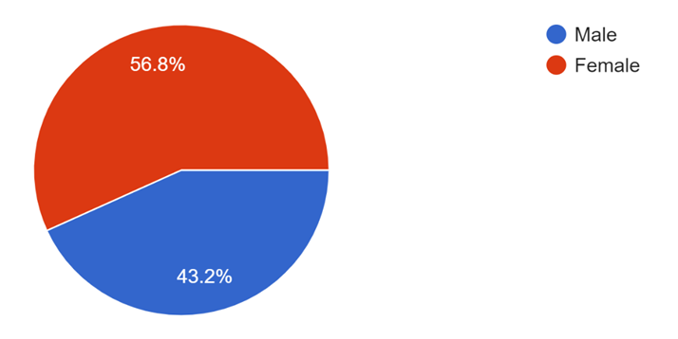
Figure 2: Survey Respondents Distribution Based on Their Gender
Source: Survey Responses
Figure 2 shows that survey responses are distributed according to the tourism business type of respondents. These tourism businesses vary in the types found on the survey: 26.10% operate in the hotel sector, while 36.40% and 17% operate in restaurants and travel agencies, respectively. A total of 20.50% represents local attractions. Restaurants have the highest proportion, while hotels take precedence to reflect a relatively impressive concentration in the food and beverage sectors.
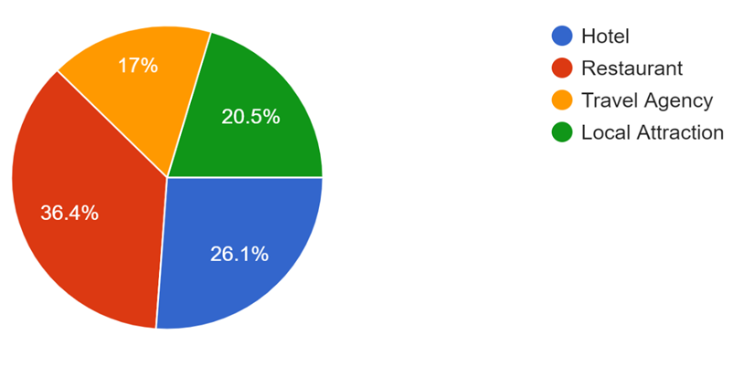
Figure 3: Survey respondents' distribution based on their tourism business type
Source: Survey Responses
Figure 3 shows that responses are distributed according to respondents' business experience. The tenure experience in the tourism business is very broad: 50% have been in the business between 1 and 3 years and are hence considered fairly new to the business, while 14.80% have less than 1 year in the business, 26.10% between 4 to 6 years, 5.30% between 7 to 10 years, while 3.80% have more than 10 years in the business. This distribution could indicate the dominance of relatively new entrants into the tourism business and thus perhaps something interesting about how more recent entrants are compared to longer-standing ones in their approach to social media marketing.
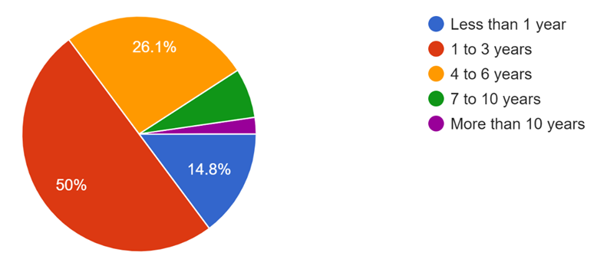
Figure 4: Survey respondents' distribution based on their experience in tourism businesses
Source: Survey Responses

Table 1: Summary of frequency rate
Source: Author compiled with survey results

4.3 Reliability Analysis
Cronbach's Alpha can also be used to indicate the internal consistency of the sample and it is most commonly used in survey research to determine reliability. Common thresholds for Cronbach's Alpha are: α ≥ 0.9 indicates excellent reliability; 0.8 ≤ α < 0.9 suggests good reliability; 0.7 ≤ α < 0.8 expresses acceptable reliability; 0.6 ≤ α < 0.7 assumes questionable reliability, 0.5 ≤ α < 0.6 suggests poor reliability, and α < 0.5 as unacceptable reliability.

4.3.1 Reliability Analysis for All the Survey Questions
According to Table 2, Cronbach's alpha value of 0.926 falls within the excellent range that is α ≥ 0.9. This reveals that the set of items within this survey as a whole (20 questions) also shows very high consistency in the measurement of the impact that social media marketing might have on tourism businesses. Thus, reliability is high and it suggests coherent and reliable data does exist for the researcher upon which to base further analysis.
Table 2: Reliability statistics and ANOVA for all the Likert scale statements
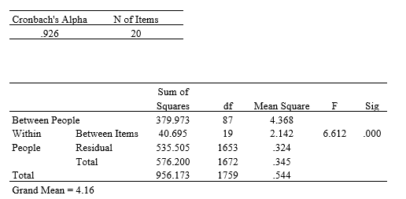
Source: Author compiled with survey results

4.3.2 Reliability Analysis for the Statements of Each Variable
Table 3 provides the reliability statistics for the statements for each variable separately. The Cronbach's Alpha of 0.797 falls within an acceptable reliability rate (0.7 ≤ α < 0.8). This reflects the fact that items designed to measure tourism business promotions have been consistent. The reliability is still strong enough that the researcher can trust consistency in responses about the promotion of tourism businesses through social media marketing.
The Cronbach's Alpha of 0.780 falls within the limits of acceptable reliability (0.7 ≤ α < 0.8). It would mean that the items developed to assess the Platform Selection are sufficiently consistent for the assessment of how the choice of social media platforms contributes to tourism businesses' promotion.
The Cronbach's Alpha of 0.754 also falls within the boundaries of acceptable reliability (0.7 ≤ α < 0.8). This would mean that the items measuring Engagement Tactics are good enough for the researcher to make consistent conclusions on how effective engagement tactics are in advancing tourism businesses.
The Cronbach's Alpha of 0.847 falls into the good reliability range (0.8 ≤ α < 0.9). This means items contributing to Content Strategy are highly consistent. The researcher can confidently conclude that responses about content strategy are reliable and also reflect a strong agreement among respondents about its impact on promoting the tourism business.
Table 3: Reliability statistics for the statements of each variable
Source: Author compiled with survey results

4.4 Data Presentation and Interpretation

4.4.1 Descriptive Statistics Analysis

Table 4 shows the descriptive statistics, including minimum, maximum, mean, and standard deviation for all the independent and dependent variables.
Table 4: Descriptive statistics for each variable
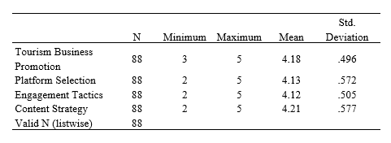
Source: Author compiled with survey results
The mean score of 4.18 infers that, on average, all the respondents agree to the fact that social media marketing has a positive effect on the promotion of tourism businesses in Manchester City. Having a standard deviation of 0.496, which is below 1.0, it would suggest that most ratings provided by the respondents are clustered around the mean, having limited variation in opinions about this aspect. From this, the researcher may infer that there is a strong convergence that social media marketing has a significant consequence on tourism businesses.
A mean of 4.13 indicates general agreement that the selection of social media platforms is an important aspect of promoting tourism businesses among the respondents. The standard deviation of 0.572 reflects a slightly higher variability than Tourism Business Promotion, meaning most of the respondents agree on the importance of the selection of the platform, but there is some variation in the degree of such agreement.
The mean of 4.12 shows that the respondents agree that engagement tactics on social media contribute to the promotion of tourism businesses. A standard deviation of 0.505 demonstrates the response is relatively consistent, though there is a small variation in the strength of agreement. Therefore, the researcher can establish that engagement tactics are recognized as an important part of social media marketing with general agreement among respondents.
A mean of 4.21 is the highest among all variables, which evidences that the respondents strongly agree with the statements that content strategy is vital in promoting tourism businesses. The standard deviation of 0.577 is moderate, showing a fair level of variability in responses. This suggests that while a greater number of respondents have strongly believed in the importance of content strategy in tourism, a variation in the level of agreement does exist.

4.4.2 Correlation Analysis
The correlation matrix which is shown in Table 5, indicates the strength and direction among all the variables in this study. Therefore, this has been the key to assessing the relationship between social media marketing and the promotion of tourism businesses. The decision rule in the correlation analysis: The correlation coefficient [r] ranges from -1 to 1; r > 0 reflects a positive relationship, while r < 0 reflects a negative relationship, and when r = 0, there is no relationship. A p-value less than 0.05 indicates that the correlation is significant, and hence the relationship is unlikely to be due to chance (Field, 2013).
Table 5: Correlation statistics for each variable
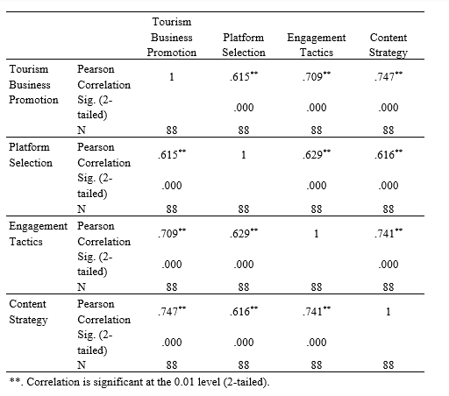
Source: Author compiled with survey results

The Pearson correlation coefficient of 0.615 demonstrates a moderately strong positive relationship between Platform Selection and Tourism Business Promotion, and the relationship is significant since the p-value is less than .001. From this result, it would appear that the better the quality of platform selection, the better the promotion of tourism businesses in Manchester.
A correlation of 0.709 exists between Engagement Tactics and the promotion of tourism businesses, which is considered a strong positive relationship. The implication of this p-value, p <.001, is that the relationship retains a high level of statistical significance. Therefore, the better the engagement of businesses on social media with their audience, the better the promotion of tourism businesses.
There is also the strongest correlation, 0.747, between Content Strategy and Tourism Business Promotion, which indicates a very strong positive relationship. The p-value <.001 confirms this relation is statistically significant. That would mean that a properly developed content strategy would have the most influence on tourism business promotion.

4.4.3 Multiple Regression Analysis
Multiple regression was used to examine to what extent the independent variables of platform selection, engagement tactics, and content strategy predict tourism business promotion.
According to Tables 6 & 7, the overall model was significant: F (3, 84) = 47.28, p <.001, indicating these variables together reliably predict tourism business promotion. The R² =.628, which reveals 62.8% in the variance of tourism business promotion was explained by the combined effect of platform selection, engagement tactics, and content strategy.
Table 6: Model Summary for regression analysis
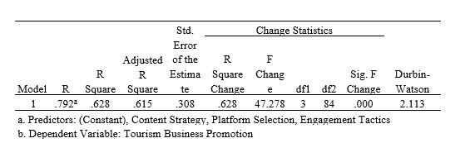
Source: Author compiled with survey results
Table 7: ANOVA for regression analysis
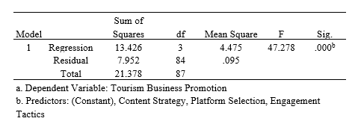
Table 8 shows the unstandardized coefficient values and p-values for each variable in this study. The ß= 0.173 for Platform Selection which indicates if the platform selection is increased by one unit, tourism business promotion is increased by 0.173 units. This effect is marginally significant, reflected by a p-value of .057, which is slightly above the conventional significance threshold of P<0.05. Thus, this would represent a trend that suggests selecting appropriate social media platforms can positively affect tourism business promotion, although the effect is not very strong when compared with other variables in the model.
The ß=0.279 for engagement tactics which suggests that if the engagement tactic is increased by one unit, tourism business promotion is increased by 0.279 units. The effect is statistically significant since the p-value (0.009) is less than the standard threshold of P<0.05. The finding indicates that a business fully engaged in delivering the needs of its customers through social media platforms will always yield better promotional results.
The ß= 0.434 reveals that if the content strategy is increased by one unit, tourism business promotion is also increased by 0.434 units. The effect is statistically significant since the p-value (0.001) is less than the standard threshold of P<0.05. This finding indicates that how tourism businesses plan and execute their content on social media platforms exerts the highest influence on promotional success.
Table 8: Coeffefficients values for regression analysis
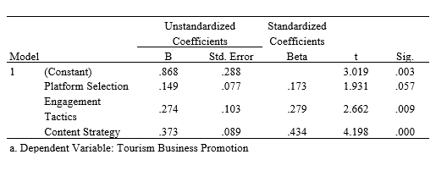
Source: Author compiled with survey results

4.5 Analysis of the Findings and Discussion
Demographically, the sample is slightly biased towards females, as 56.80% are female and 43.20% are male. The results are consistent with the observations of Kim et al. (2020), who reveal higher uses of social media among females. Restaurants being in the majority of the sampled population comprise 36.40%, while hotels comprise 26.10%, which also agrees with Agostinho et al. (2022), who observe that restaurants are so instrumental in using social media to promote tourism. Also, the highest number of the respondents have been in the business between 1 to 3 years, and this forms the trend and direction of more recent entrants. This was well described by the increased number of new businesses adapting to social media marketing as explained by Chung & Han (2017).
The reliability analysis for survey instruments underlines the strength of the measurement tools used. With an overall Cronbach's Alpha of 0.926, this demonstrates the excellent reliability of the survey and supports the findings by Sarkar & George (2018) for the use of reliable tools in testing the effectiveness of social media. The Cronbach's Alpha scores for platform selection, engagement tactics, content strategy, and tourism business promotion reflect acceptable to good reliability. These findings agree with the studies by Chung & Han, (2017) that emphasized high reliability concerning social media marketing research.

The impact of platform selection on promoting tourism businesses
These results confirm that the selection of platforms is significant in improving tourism businesses within Manchester. The selection of social media platforms and effective tourism promotion is positively related to a moderate relationship, having a Pearson correlation coefficient of 0.615. This agrees with the work of Amir et al. (2022), who insisted on the selection of appropriate platforms to create better marketing outcomes. The positive correlation does mean that those tourism businesses that are using the most appropriate social media outlets tend to have more successful promotions.
Descriptive statistics further reinforce this view. The mean score for this variable is 4.13, showing that there is a strong consensus among the respondents on matters of platform selection. In support, Buhalis, (2021) identified that different social media platforms have different characteristics that could be used strategically to enhance tourism promotion. The consensus of the respondents shows that correct platform selection has practical relevance in terms of effective marketing.
However, in regression analysis, platform selection has only marginal significance with a β value of 0.173 and a p-value of 0.057, indicating that its influence is positive but marginally above the conventional 0.05 level of significance. As Agostinho et al., (2022) revealed this marginal significance shows that while platform selection indeed influences tourism promotion, its strength of influence is relatively low compared to the content strategy and tactics of engagement.
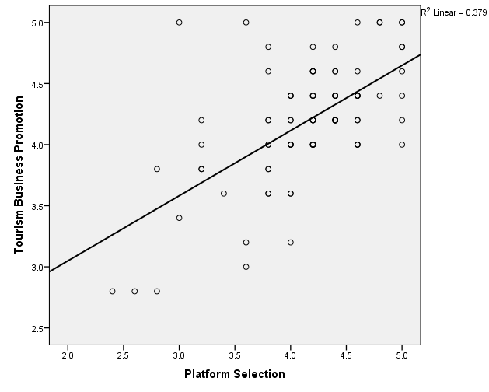
Figure 5: Linear graph for Tourism business promotion and Platform selection
Source: Author compiled with survey results
The positive correlation and marginal significance in the regression analysis do indicate that the selection of the platform contributes to the promotion of tourism businesses, though the influence is relatively weak compared to other variables. Therefore, the researcher has conclusive evidence to reject the null hypothesis which states that there is no significant impact of platform selection on promoting tourism business in Manchester City. This partial rejection of the null hypothesis supports the view that while the selection of the platform is very vital, it needs to be taken into consideration alongside other critical factors like content strategy and tactics of engagement to which a holistic approach to social media marketing can be built.
The impact of engagement tactics on promoting tourism businesses
This interpretation shows that the engagement tactic significantly affects tourism businesses in Manchester when it comes to promoting them. The Pearson correlation coefficient, 0.709, also indicates a strong positive relationship between engagement tactics and effectiveness in tourism promotion. This correlation is supported by the finding of Ali et al. (2022) stating that the higher the rate of engagement, through likes, shares, and comments, the higher the efficiency of marketing. These engagement strategies allow for greater interaction of the firm with the target audience, thereby increasing visibility and promotional success.
Descriptive statistics also support this finding, with an average score of 4.12 indicating agreement among respondents on the effectiveness of the engagement tactics. This means that full consensus exists to the significance of engagement strategies for tourism promotion. According to Chung & Han (2017), interactive engagements such as competitions, polls, and other forms of direct engagement with users are important in building relationships with potential customers and establishing brand loyalty. The high mean score would indicate that respondents consider the use of engagement tactics as an important part of their marketing strategies.
The regression analysis supports more of the above findings, highlighting the β value of 0.279 with p = 0.009 shows the statistically significant positive effect of engagement tactics on promoting tourism businesses. This is also in line with the work done by Chung & Han (2017), where the importance of interactive strategies of engagement to the success of social media marketing campaigns was underlined. The size of the regression coefficient underlines the relevance of strong engagement strategies for promotional success.

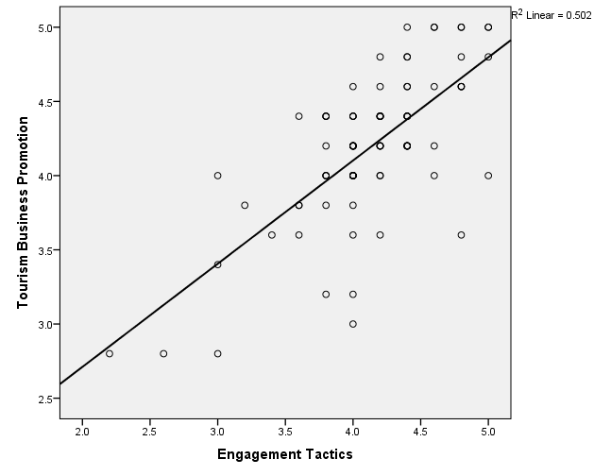
Figure 6: Linear graph for Tourism business promotion and Engagement Tactics
Source: Author compiled with survey results
The findings indicate the failure to accept the null hypothesis. Both the high value of the positive correlation and the significant regression coefficient support the fact that engagement tactics do have a significant effect on promoting tourism businesses. A high correlation between engagement tactics and promotional effectiveness, together with the statistical result showing the regression as significant, actually means that one of the most crucial strategies for which tourism businesses can enhance their marketing outcome is through engagement strategies. Evidence shows that good engagement strategies are vital factors for tourism businesses desiring to increase their promotional activities and reach out to an audience.
The impact of content strategy on promoting tourism businesses
The results reveal that the content strategy is the most influential factor in promoting tourism businesses in Manchester. With a Pearson correlation coefficient of 0.747, there exists a strong positive relationship between content strategy and tourism promotion, the highest among the variables studied. This substantial correlation suggests that well-crafted and strategically designed content is an indispensable aspect of enhancing tourism marketing campaigns. This is supported by Alghizzawi et al. (2018), who argue that strong content plays a major role in promotional success. A high correlation further denotes the relevance of the content to the promotional objectives to ensure maximum returns are attained.
Descriptive statistics reinforce the importance of content strategy with an average score of 4.21, indicating a strong consensus among respondents on the critical role of content in tourism promotion. In the content strategy, several captivating stories are said, supported by attractive media and target messages that are critical in securing the attention of the audience while at the same time driving engagement. Buhalis & Sinatra (2020) contend that for travelers to remember the content, it has to be dynamic and interactive, hence communicating the value of the destination. The high mean score reflects the recognition of the importance of the content strategy in maximizing promotional effect.
It was also supported by the regression analysis, giving a very significant value of β = 0.434, p = 0.001 to the content strategy. This significant result reflects that among other factors such as platform selection and engagement tactics, content strategy bears a dominant impact on tourism promotion. This finding is supported by the work of Matikiti et al. (2018), who have underlined that proper, attractive content is considered one of the success factors in social media marketing. The high regression coefficient points to the fact that content strategy is one of the most relevant variables that improve promotional performance, and as such, for tourism businesses, it is necessary to invest in attractive and strategically developed content.
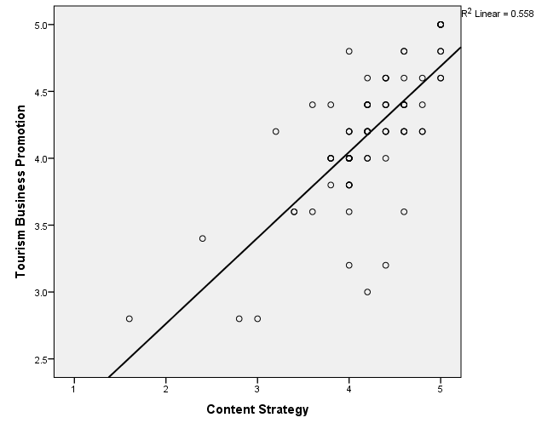
Figure 7: Linear graph for Tourism business promotion and Content strategy
Source: Author compiled with survey results

The results lead to the failure to accept the null hypothesis. Both a strong positive correlation and a highly significant regression coefficient imply that content strategy significantly affects the promotion of tourism businesses. The evidence appears to be pointing out that effective content strategy is the key to successful marketing, therefore it is the variable with the biggest power in driving the variables under study.

Platform Selection
Tourism Business promotion
Content Strategy
Engagement Tactics
Significant Positive Impact
Statistically significant positive impact
Statistically Significant Positive Impact
Figure 8: Conceptual framework after analyzing the survey results
Source: Author compiled with survey results

4.6 Summary
The demographic analysis showed a slight bias towards females and emphasized a diverse range of business types, with restaurants being predominant, and the majority of the respondents having 1 to 3 years of industry experience. The confirmation of the survey instrument's high level of consistency was provided by reliability analysis, while Cronbach's Alpha scores reflected the strong reliability of the variables. Descriptive statistics also supported the fact that a general agreement existed in the responses to the question about the positive impact of social media marketing, where the content strategy was detected as the most influential factor. The correlation analysis also indicated a strong positive relationship amongst all variables regarding promoting tourism business and, among these variables, content strategy had the highest rate. However, the regression analysis brought forth high relevance to tactics of engagement and strategy of content to promotion, while selection of platforms showed only marginal significance. Overall, these findings can be supported that the role of social media marketing strategies in improvement to promotion of tourism businesses.

Chapter 5: Conclusion, Recommendations, and Managerial Implications

5.1 Introduction
This chapter summarizes the findings, conclusions, recommendations, managerial implications, and limitations of the research. It starts with addressing conclusions about the research objectives by giving an overview of how platform selection, tactics of engagement, and content strategy aspects affect the promotion of tourism businesses in Manchester. The research question is then addressed, followed by practical recommendations on how to improve social media marketing strategies. The discussion on managerial implications follows, focused more on actionable strategies for business leaders. Limitations are then acknowledged in this chapter.

5.2 Conclusions for Research Objectives

5.2.1 Objective 1: To investigate the impact of platform selection on promoting tourism businesses in Manchester, UK.
It concludes that platform selection is a major determinant in the promotion of tourism businesses in Manchester. Analysis shows a moderate positive correlation between the platform selection of social media platforms used and the effectiveness of promotion. This infers that businesses that strategically choose the platforms for their marketing objectives will most likely see better promotional success.
Descriptive statistics further confirm this result, since there is a consensus on the role of platform selection. Most of the responses to the survey identify the selection of proper platforms as being fundamental to the realization of efficient and effective tourism marketing. Regression analysis, which resulted in only the marginal significance of this driver, proved that platform selection makes a positive impact on promotion initiatives. Nevertheless, this effect is relatively weaker than the one coming from the content strategy and approach of engagement.
On the whole, the study meets the objective of determining the impact of platform selection to promote tourism businesses. As important as platform selection is, its role remains somewhat subsidiary to the other elements of the marketing mix. The findings stress the need for an integrated approach aimed at bringing on board all the aspects that are required for promotional purposes.

5.2.2 Objective 2: To investigate the impact of engagement tactics on promoting tourism businesses in Manchester, UK.
The aim of assessing the effects of engagement strategies on the promotion of tourism business is met accordingly. The study shows a highly positive relationship between the engagement strategies in terms of likes, shares, and comments and the effectiveness of tourism marketing. The strong positive relationship indicates that the more interactive the engagement strategy, the higher the promotional effectiveness.
These descriptive statistics show general agreement over the effectiveness of engagement tactics in nurturing user interactions and visibility, which confirms their key role. This is confirmed through regression analysis by the significant effect of engagement tactics on promotional outcomes, while the high β value for engagement tactics confirms the fact that engagement tactics make the difference in enhancing the effectiveness of tourism marketing campaigns.
Thus, the null hypothesis (H0: There is no effect of engagement tactics on the promotion of tourism businesses) may be rejected, and this could provide substantive evidence that engagement tactics affect promotional success within the tourism sector. The results thus indicate that a proper engagement strategy significantly adds to the enhancement of promotional aspects in tourism businesses, and it fulfills the objective of investigating the impact of engagement tactics on tourism business promotion in Manchester City.

5.2.3 Objective 3: To investigate the impact of content strategy on promoting tourism businesses in Manchester, UK.
The research has effectively carried out the purpose of examining what role content strategy plays in promoting the tourism business. The subsequent analysis shows that content strategy is the most positively correlated variable to promotional success. The high value of its correlation indicates that well-articulated and strategically crafted content is greatly important for the effectiveness of tourism marketing.
Descriptive statistics reveal the importance of content strategy, given that participants highly agree on the issue of whether content strategy drives promotional success. This is then again asserted through the regression analysis, where the highly significant value of β shows that content strategy dominates the influence on marketing outcomes.
Thus, the rejection of the null hypothesis that there is no influence of content strategy on the promotion of tourism businesses establishes that the content strategy has a great consequence on promotional effectiveness. Therefore, these results support the fact that the content strategy is an important element in the successful promotion of tourism businesses, which was in line with the research objective of determining its effect and dynamic and engaging content in marketing.

5.3 Conclusion for Research Question
The question addressed was: "What is the effect of social media marketing in promoting tourism businesses within Manchester City, UK?" The outcome indicates that the factors of social media marketing have a significant effect on tourism promotion, and all its sub-components in terms of platform selection, tactics of engagement, and content strategy are highly significant to promote tourism business in Manchester city. Platform selection is at a moderate positive level, whereas engagement tactics are strongly positively related, and content strategy is the most influencing factor in all the variables. Combining these factors, they signal that the integration of mindful platform choices, engaging practices, and dynamic content creation is to help in completing the holistic approach to social media marketing to further enhance the visibility and appeal of tourism businesses in Manchester City. The study therefore concludes that social media marketing has a significant positive impact, and it can be a strong tool for tourism business promotion, which requires an integrated approach in a strategic manner for the best promotional outcomes.

5.4 Recommendations
These are some practical recommendations based on the research findings that could help in strengthening social media marketing strategies for tourism businesses in Manchester. Each of the recommendations is discussed in detail below.
1. Social Media Platform Optimization
Tourism businesses must select social media platforms on which there is a strategic match between the target audience and the desired marketing outcomes. For instance, visually driven social networking sites, such as Instagram and Pinterest, have been quite useful in describing aesthetic appeal through images and videos of places that attract tourists. These platforms allow high-resolution visuals, thus making the posts attractive to potential tourists. On the other hand, platforms such as Facebook and Twitter are strong engagement channels to share updates on news and other promotional offers. This helps companies understand where their potential customers spend most of their time and what kind of content they interact with, thus informing the right platform to use. In such a case, a company can only select a single appropriate platform for maximum reach and engagement.
2. Enhance Tactics to Increase Engagement
To improve visitor and user interaction, tourism businesses need to utilize interactive tactics for visitor/user engagement. Encouraging UGC is one of the most influential ways to drive user engagement; essentially, it is just a question to customers regarding their experiences and reviews. Running contests or challenges based on travel experience will also contribute to encouraging user participation and building better brand visibility. Activating a response to every comment and message creates a strong relationship with the followers by showing that the business values their contributions. One can make it more personal by calling the users by their name and pointing out special interests in certain things, which will add greater engagement and ensure a better perception of a brand.
3. Development of Robust Content Strategy
A properly developed content strategy keeps the audience interested and motivates them to be more active. Therefore, tourism businesses should develop quality content that points out unique aspects of their offerings: special events, local attractions, and even travel tips. To attract the audience and inspire sharing, one may use interesting stories, behind-the-scenes glimpses, and posting of informative material. Renewal of content could keep the brand topical and fresh in the minds of possible tourists. This could also be done by incorporating varied content types in the marketing strategy, such as videos, infographics, and blogs that will help appeal to the different tastes of the target audience.
4. Utilization of Influencer Partnerships
Partnering with influencers and other personalities in the local setting ensures a lot of increased marketing potential. These influencers have great base followers within tourism businesses and can introduce tourism businesses to a new set of audiences, building credibility through non-forced recommendations. Influencer partnerships that target businesses with values and a target market in alignment have the potential to connect with key individuals who will help raise brand awareness and drive engagement. Influencers have the power to create content that will inspire their audience by communicating, in a quite compelling way, why this tourism business should be an appealing destination and worthy of a visit.
5. Monitoring and Changing Strategies
Social media performance needs constant monitoring and must be followed by modifications in marketing strategies to attain full optimization. Besides that, a tourism business should be tracking some key metrics such as engagement rate, reach, and conversion rate, that indicate the effectiveness of their social media campaign. These give insight into what works and what needs to be recalibrated. Businesses should act upon the data to optimize their performance and work their way to keep up with emerging trends. Performance review regularly enables a business to make necessary amendments and increase audience participation for better promotional results.

5.6 Managerial Implications
The conclusions and suggestions derived from this study can provide significant input from the managerial perspective for application in the tourism sector. These conclusions, when applied to tourism business management, will be able to assist managers in improving their social media marketing activities and thus obtain better results from their promotions.
- Managers should make prudent choices about the usage of platforms based on informed decisions regarding their target audience and the objectives of the marketing campaign. Knowledge of peculiar features and user demographics will go a long way in helping to plan and execute effective campaigns across platforms.
- Engagement tactics, especially interactive ones, need to be emphasized by managers as the focal point of their strategies on social media. This involves meaningful dialoguing with users, crafting content that elicits a response, and building a community around the brands. Effective engagement may translate into brand loyalty and positive word-of-mouth.
- One thing that remains key is a well-defined content strategy. The manager should ensure his content is visually good since it will be associated with a brand message and audience interest. Great content results in more likes, comments, and shares, hence increasing the return from social media marketing.
- Analytics drive managers to monitor the performance of their social media campaigns using data. Accordingly, they will be able to make more educated decisions by looking at the engagement metrics and audience feedback so that they can always fine-tune their strategies for better marketing results.
- The social environment keeps changing, and the manager needs to stay updated about all changes going on around up-and-coming trends and best practices. Continuously reconsidering and revising their marketing strategies in response to new insights and industry developments is the main thing that will help them remain competitive.

5.7 Limitations of Study
- The sample size was 88 respondents, which may not be representative. A sample size would have been more representative, giving wider and better insights into how social media marketing strategies are effective in promoting tourism businesses in Manchester.
- The findings will be purely confined to tourism businesses found in Manchester City and limit the applicability of findings in other areas or contexts. The trends and impacts of social media marketing, which might have been assessed for Manchester, cannot apply to other geographic regions due to different market dynamics, audience behaviors, and other cultural factors.
- The study administered questionnaires with items that utilize the Likert scale. This has several limitations, based on the subjective nature of self-reporting data. They may reflect personal biases within a participant, which can potentially affect the accuracy of the results. Apart from this, using only quantitative methods may fail to illustrate the nuanced aspects of social media marketing that may be displayed through qualitative methods, such as interviews or case studies.
- In this research, only three areas of social media marketing were investigated: the selection of platforms, strategy for content, and tactics used for engagement. Although these are key areas, influencer marketing, social media advertising, and analytics were not covered in the research. In this limited focus, it might have missed other factors that could also play a very important role in the success of tourism business promotion.

5.8 Recommendations for Future Research
- Future research should be conducted with a larger sample size to achieve greater representativeness and to better capture the real view of social media marketing strategies in the tourism business. With an increased sample size, one can expand the scope of perspectives and experiences so that stronger, generalizable findings can be acquired.
- Qualitative approaches, such as in-depth interviews, focus groups, or case studies, shall be used in future studies to complement the quantitative data from questionnaires. Qualitative research will show underlying motivations, attitudes, and behaviors that quantitative methods may not be able to catch, hence a deeper understanding of the complexity behind social media marketing for tourism businesses.
- Other areas of crucial importance that were not explored in the present study include influencer marketing, social media advertising, and the usage of analytics. These factors are very vital in ensuring the success of social media campaigns and, therefore, can also give meaningful insights into how tourism industry businesses can further their strategies to sustain or improve their marketing at a higher level. The investigation into these aspects can probably contribute to the identification of new opportunities and challenges that concern social media marketing.
- Longitudinal studies could be carried out to enable the researcher to trace changes and trends in the effectiveness of social media marketing strategies over time. This approach may give insights into the evolving strategy process and the eventual impact that would be created on long-term tourism business promotion. A researcher can assess the sustainability and effectiveness of social media marketing strategies through the analysis of data collected at multiple points in time and, at the same time, identify emerging trends.
- A comparison of social media marketing strategies adopted across industries, like hospitality, retail, and entertainment, may show the differential use of industry-specific practices and their effectiveness. Gaining insight into how social media strategies differ across sectors will help to understand best practices that could also help businesses in tourism learn from approaches that work well in other industries.

References

- Agostinho, V., Estevão, C., Duarte, P., & Gonçalves, G. (2022) ‘Social Media Usage Patterns and Motivations in Tourism Companies: An Outlook’. In: Advances in Social Media for Travel, Tourism and Hospitality. Routledge. doi: 10.1007/978-981-16-9268-0_45.
- Akın, M., & Şener, B. (2024) ‘The Impact of Social Media On Destination Choice: A Study on Generation Z’. Journal of Tourism & Hospitality, 8. Available at: https://www.yepad.org/. doi: 10.21325/jotags.2023.1406.
- Al-ani, A. (2023). Chapter 5: Research ethics, citations, and references.
- Alghizzawi, M., Salloum, S. A., & Habes, M. (2018). The role of social media in tourism marketing in Jordan. International Journal of Information Technology and Language Studies, 2(3), 45-56.
- Ali, I., Azhar, N., Tariq, M., & Khan, S. A. (2022). Role of rise in social media on travel and tourism industry. Journal of Tourism & Hospitality, 9, 1150-1155.
- Amir, A., Hafizan, N., Mohd Anuar, N., Asyraff, M. A., & Shahril, Z. (2022). The influence of Instagram travel content on intention to visit tourist destinations. International Journal of Academic Research in Business and Social Sciences, 12.
- Aydin, G. (2020). Social media engagement and organic post effectiveness: A roadmap for increasing the effectiveness of social media use in the hospitality industry. Journal of Hospitality Marketing & Management, 29(1), 1-21.
- Bassano, C., Barile, S., Piciocchi, P., Spohrer, J. C., Iandolo, F., & Fisk, R. (2019). Storytelling about places: Tourism marketing in the digital age. Cities, 87, 10-20.
- Buhalis, D. (2021). Marketing the competitive destination of the future. Tourism Management, 21(1), 97–116.
- Buhalis, D., & Sinarta, Y. (2020). Real-time co-creation and nowness service: Lessons from tourism and hospitality. Journal of Travel & Tourism Marketing, 37(5), 563-582.
- Boediman, S. F., Hendriarto, P., Satmoko, D., Sulistiyani, S., & Sani, A. (2021). The relevance of using social media applications strategies to increase marketing potential of Indonesian maritime tourism (Analytical study of tourism journals and online marketing). Budapest International Research and Critics Institute-Journal, 4(4).
- Camilleri, M. A. (2018). The promotion of responsible tourism management through digital media. Tourism Planning & Development, 15(6), 653-671.
- Chiwaridzo, O., & Masengu, R. (2023). The impact of social media branding and technology adoption on green tourism: The role of tourist behavior as a mediator in developing countries post-COVID-19- context of Zimbabwe. Future Business Journal, 9. https://doi.org/10.1186/s43093-023-00249-6
- Chung, N., & Han, H. (2017). The relationship among tourists’ persuasion, attachment and behavioral changes in social media. Technological Forecasting and Social Change, 123, 370–380.
- CityCo. (2024). Manchester today: Useful stats. CityCo. Retrieved August 24, 2024, from https://cityco.com/manchester-today-useful-stats/
- Cropanzano, R., Anthony, E., Daniels, S., & Hall, A. (2017). Social exchange theory: A critical review with theoretical remedies. The Academy of Management Annals, 11, 1-38.
- Del Vecchio, P., Mele, G., Ndou, V., & Secundo, G. (2018). Creating value from social big data: Implications for smart tourism destinations. Information Processing & Management, 54(5), 847-860.
- Dudovskiy, J. (2022). The ultimate guide to writing a dissertation in business studies: Step-by-step assistance (7th ed.). Research Methodology. http://research-methodology.net/about...
- Du Plessis, C. (2017). The role of content marketing in social media content communities. SA Journal of Information Management, 19.
- Ebrahimi, P., Hajmohammadi, A., & Khajeheian, D. (2019). Place branding and moderating role of social media. Current Issues in Tourism, 1–9.
- Field, A. (2013). Discovering Statistics Using IBM SPSS Statistics (4th ed.). SAGE Publications.
- Geria, A. A. G. A., Maheswari, A. I. A., & Pemayun, A. A. G. P. (2018). Social media as promotion trend for increasing tourist visit towards digital era. International Journal of Social Sciences and Humanities, 2(3), 86-94.
- Gebreel, O. S. S., & Shuayb, A. (2022). Contribution of social media platforms in tourism promotion. International Journal of Social Science, Education, Communication and Economics (SINOMICS JOURNAL), 1(2), 189-198.
- Han, W., McCabe, S., Wang, Y., & Chong, A. Y. L. (2018). Evaluating user-generated content in social media: An effective approach to encourage greater pro-environmental behavior in tourism? Journal of Sustainable Tourism, 26(4), 600-614.
- Hossain, R., Amin, A., Mani, L., Islam, M., Poli, T., & Milon, M. N. (2024). Exploring the effectiveness of social media on tourism destination marketing: An empirical study in a developing country. WSEAS Transactions on Business and Economics, 21, 1392-1408.
- Hossain, R., Amin, A., Mani, L., Islam, M., Poli, T., & Milon, M. N. (2024). Exploring the effectiveness of social media on tourism destination marketing: An empirical study in a developing country. WSEAS Transactions on Business and Economics, 21, 1392-1408.
- Hysa, B., Karasek, A., & Zdonek, I. (2021). Social media usage by different generations as a tool for sustainable tourism marketing in society 5.0 idea. Sustainability, 13(3), 1018.
- Irfan, A., Rasli, A., Sami, A., & Liaquat, H. (2017). Role of social media in promoting education tourism. Advanced Science Letters, 23(9), 8728–8731.
- Kartika, T., & Riana, N. (2020). Storynomics tourism as an effective marketing strategy on tourism destination (Case study on Tangkuban Parahu, West Java-Indonesia). Tourism and Sustainable Development Review, 1(1), 33-40.
- Kim, D., Kim, S., & Gretzel, U. (2020). An exploratory investigation of Korean travelers' Instagram activities. Current Issues in Tourism, 23(10), 1204–1220.
- Kilipiri, E., Papaioannou, E., & Kotzaivazoglou, I. (2023). Social media and influencer marketing for promoting sustainable tourism destinations: The Instagram case. Sustainability, 15(8), 6374.
- Kumar, P. (2021). Digital marketing in hospitality and tourism. University of South Florida (USF) M3 Publishing.
- Kumar, P., & Dhankhar, Dr. (2023). Analyzing the impact of social media on tourism firms. Available at: https://zenodo.org/record/7251086 (Accessed: 10 August 2024).
- Labanauskaitė, D., Fiore, M., & Stašys, R. (2020). Use of e-marketing tools as communication management in the tourism industry. Tourism Management Perspectives, 34, 100652.
- Liu, X., Mehraliyev, F., Liu, C., & Schuckert, M. (2020). The roles of social media in tourists’ choices of travel components. Tourist Studies, 20(1), 27-48.
- Magano, J., & Cunha, M. N. (2020). Digital marketing impact on tourism in Portugal: A quantitative study. African Journal of Hospitality, Tourism and Leisure, 9(1), 1-19.
- Mariani, M. M., Mura, M., & Di Felice, M. (2018). The determinants of Facebook social engagement for national tourism organizations' Facebook pages: A quantitative approach. Journal of Destination Marketing & Management, 8, 312-325.
- Matikiti, R., Mpinganjira, M., & Roberts-Lombard, M. (2018). Application of the Technology Acceptance Model and the Technology–Organisation–Environment Model to examine social media marketing use in the South African tourism industry. South African Journal of Information Management, 20(1), 1-12.
- Mohamad, N., Vivien, T., & Pei, T. (2022). Travel experience on social media: The impact towards tourist destination choice. Journal of Tourism Research & Hospitality, 11, 180-190.
- Molinillo, S., Liébana-Cabanillas, F., Anaya-Sánchez, R., & Buhalis, D. (2018). DMO online platforms: Image and intention to visit. Tourism Management, 65, 116-130.
- Navio-Marco, J., Gómez, L. M., & Sevilla-Sevilla, C. (2018). The role of social media in the marketing of tourism destinations. Tourism Management, 69, 18-31.
- Pan, S., & Zhang, L. (2020). Investigating the influence of social media on travel behavior and destination selection. Journal of Travel Research, 59(5), 926-945.
- Rahman, M., & Ahmed, M. (2020). Effectiveness of social media marketing in the tourism sector: A study on social media engagement and customer behavior. International Journal of Tourism Policy, 10(3), 290-304.
- Ribeiro, M. A., & Silva, P. R. (2019). The impact of social media in the tourism industry. Journal of Marketing and Business, 1(1), 53-64.
- Rodríguez, M. A., & González, R. (2020). Social media marketing strategies for tourism destination branding. Journal of Business Research, 118, 323-335.
- Ruivo, J. M., & Rodríguez, M. T. (2020). Effectiveness of social media marketing on destination selection. Tourism Management Perspectives, 33, 100592.
- Saglam, M., & Yilmaz, B. (2022). Evaluating the impact of social media on tourism marketing: Evidence from Turkey. Tourism Economics, 28(2), 343-357.
- Saufi, R., Othman, M. S., & Jamal, M. T. (2020). Impact of social media on tourism marketing: Evidence from Malaysia. Asian Social Science, 16(8), 12-24.
- Schuett, M. A., & Harrill, R. (2020). Examining the role of social media in destination marketing. Tourism Review, 75(2), 123-137.
- Shaikh, M., & Ali, S. (2022). Social media as a tool for tourism promotion: A case study of Pakistan. Journal of Business and Management, 24(5), 56-65.
- Shirazi, F., & Mokhtari, H. (2019). Social media marketing in tourism industry: A review and future research agenda. Journal of Strategic and International Studies, 12(1), 98-115.
- Smith, M., & Puczkó, L. (2019). Tourism and the social media experience. Routledge.
- So, K. K. F., & King, C. (2020). Social media engagement and its impact on brand loyalty: A case study in tourism. Journal of Travel & Tourism Marketing, 37(7), 770-783.
- Tamtam, R., Boudhar, H., & Moussawi, S. (2023). Social media and tourism: Exploring digital marketing strategies and customer engagement. Journal of Travel & Tourism Research, 22(1), 1-15.
- Tsai, M.-T., & Li, Y.-H. (2018). The influence of social media on consumer attitudes and behavior towards travel and tourism. Journal of Business Research, 86, 347-359.
- Wang, Y., & Qu, H. (2020). The effects of social media marketing on tourism destination image and visitor satisfaction. Journal of Destination Marketing & Management, 18, 100503.
- Wong, A., & Png, M. (2020). Evaluating the effectiveness of social media marketing in the tourism industry. Tourism Management Perspectives, 34, 100684.
- Wu, L., & Zhang, S. (2021). The impact of social media engagement on customer satisfaction in the tourism industry. Tourism Review, 76(3), 483-497.
- Xie, K. L., & Hu, W. (2019). Social media marketing for tourism: A systematic review and research agenda. Journal of Hospitality and Tourism Management, 39, 103-118.
- Zhang, L., & Li, X. (2022). The role of social media influencers in tourism marketing: A case study of travel destinations. International Journal of Tourism Research, 24(6), 189-202.

Appendices

Normality Test of the Variables
According to the below histograms, the researcher might conclude that all the variables follow a normal distribution in the sample due to their bell shapes of the curve.
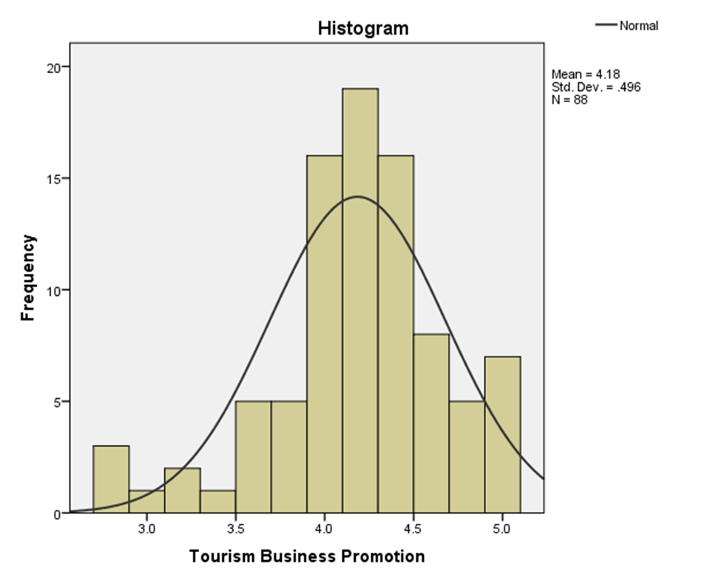
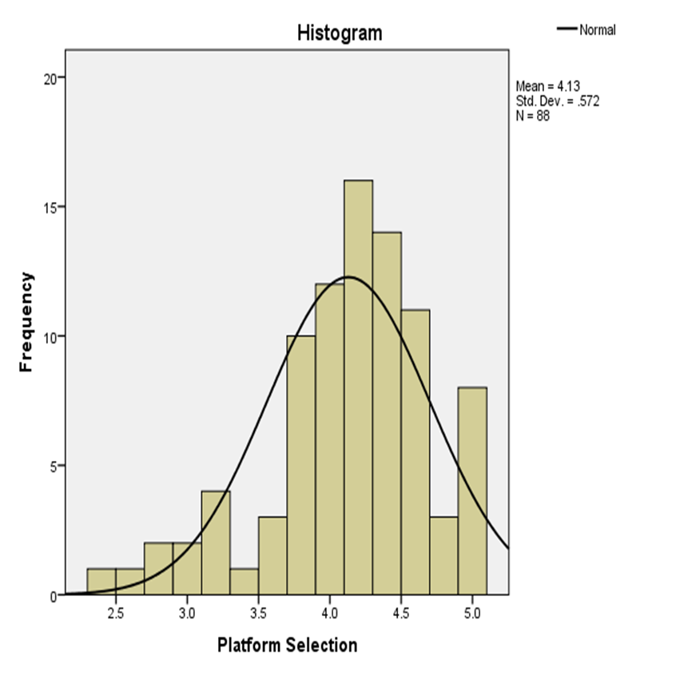

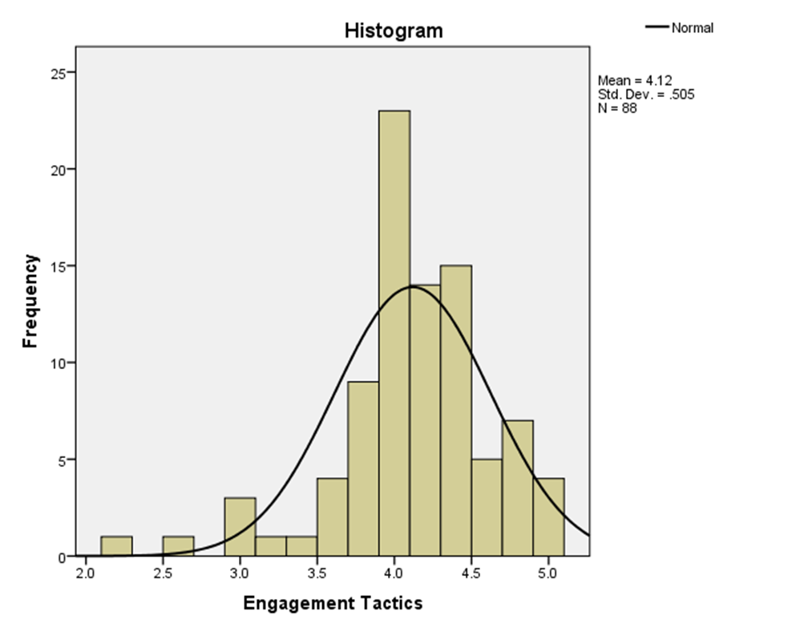

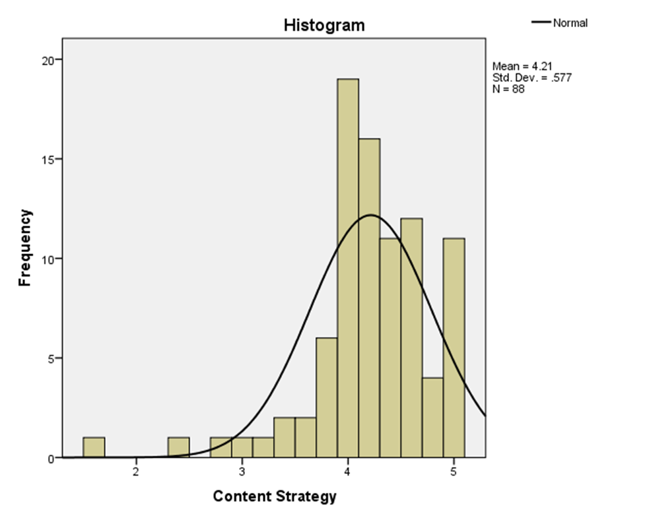

Multicollinearity Test of Independent Variables
The result of the multicollinearity test explained that multi-collinearity does not exist significantly among the predictors. Also, for each predictor, the below tolerance and VIF values are respectively given: Platform Selection = .555/1.803, Engagement Tactics = .404/2.478, and Content Strategy = .414/2.415. Because the VIF values for all the predictors are considerably less than the threshold value of 5, this above output means that there is no problematic multicollinearity among the predictors; hence, each predictor contributes uniquely to predicting Tourism Business Promotion.
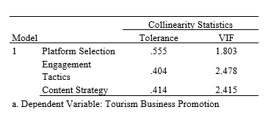

Survey Questionnaire

